Burkina Faso’s well-developed road-rail connectivity has put it logistically close to European markets.

**QUICK FACTS ABOUT BURKINA FASO**

* Full name: Burkina Faso
* Population: 16.9 million (UN, 2011)
* Capital: Ouagadougou
* Area: 274,200 sq km (105,870 sq miles)
* Major languages: French, indigenous languages
* Major religions: Indigenous beliefs, Islam, Christianity
* Life expectancy: 55 years (men), 57 years (women) (UN)
* Monetary unit: 1 CFA (Communaute Financiere Africaine) franc = 100 centimes
* Main exports: Cotton, animal products, gold
* GNI per capita: US $570 (World Bank, 2011)
* Internet domain: .bf
* International dialing code: +226

**Country Profile**

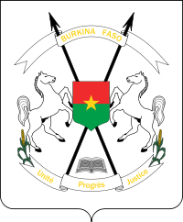

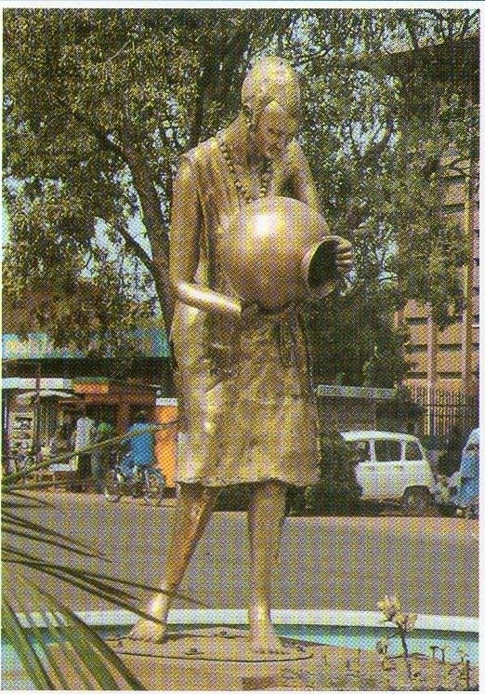

**Burkina Faso**

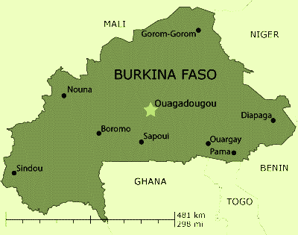

**Embassy of Burkina Faso in India**

F2/4 Vasant Vihar, New Delhi

Phone: +91-11-26140641/42

Fax: +91-11-26140630

Email: embassy@burkinafasoindia.org

Web-site : www.burkinafasoindia.org

www.burkinafasoindia.org